PROJECT REPORT – TELEMENTORING WORKSPACE

Viil Lid and Matthew Sharritt
ICS 667, Fall 2002
Dr. Daniel Suthers

Table of Contents

1. Introduction 2
2. Requirements 3
2.1 Root Concept 3
2.2 Interview 3
2.3 Artifact Analysis 4
2.4 Problem/ Activity Scenarios 5
2.5 Claims Analysis 5
2.6 User Role Models 5
3. Design and Prototype 6
3.1 Essential Use Cases 6
3.2 E-R Model 6
3.3 Context Navigation Map 6
3.4 Contexts 7
3.5 Interaction Scenario 7
3.6 Prototype 7
4. Evaluation and Redesign 8
4.1 Icon Testing 8
4.2 Prototype Testing 8
5. Conclusion: Discussion of Methods 9
6. Appendix 11

Introduction
Telementoring is a mentoring relationship or program in which the communication between mentor and mentee is computer mediated, where mentoring is defined as a sustained relationship between a youth and an adult. In a well-structured mentoring relationship, the adult provides help, support and guidance to the mentee.
The idea of telementoring is to use telecommunications technology to support mentoring relationships between students and volunteering field experts. This is particularly useful in situations where face-to-face mentoring would be hard to carry out. We predict that telementoring, both within traditional education and the business world, will be a growing area in the future. It will connect mentees with field experts in a worldwide context. As there currently does not exist any customized software to support telementoring we believe this is a great opportunity to get a competitive advantage and lead the way for telementoring software. We will focus on the development of a new software tool for the use of educational telementoring.
Typically students of lower grade levels have teachers with knowledge of general topics in education. Therefore when students are working on projects or field studies that require expert knowledge of a particular field, their teachers cannot always provide them with the assistance they need. In these cases students are often left to seek additional knowledge via sources like the school library and the Internet, where the abundance, or possibly lack of, information can make it difficult and time consuming for the student to find what is relevant for their particular project. Scientists and other field experts may not be available in the local community, and students might not know where and how to get in touch with authorities within their field of interest. Currently the communication between students, teachers, and field experts in a telementoring relationship is primarily done by e-mail or in discussion groups. Our proposal is to make software specifically for telementoring, thus considering the needs of the various user groups in a telementoring relationship throughout the design process. The software will provide a workspace where this interaction between telementor and mentees can take place. Early attention was given to usability, since a key advantage over other existing tools will be that our tool is simpler for mentors and mentees to use.
The methods used throughout this project includes root concept, interview guide, user role modeling, artifact analysis, problem and activity scenarios accompanied by claims analysis, essential use cases, entity-relationship modeling, contexts, prototyping, and usability testing. We believe that prioritizing spending time on these methods allowed us to design a system that has clear advantages over existing systems. With a growing need for telementoring software due to the shortcomings of existing tools, we believe moving on this now will give us the opportunity to gain a key market advantage being the first to create this kind of tool. We have the opportunity to be the first and set the standard, as well as be the only offering such a tool

Requirements
We started out defining the root concepts of our project in order for us as a development team to have a common understanding of what we were trying to achieve. Then we continued to define the requirements for Telementoring Workspace software as we conducted interviews with representatives for the core stakeholders in our project. Based on the results of these interviews we were able to conduct a requirements analysis for the system.
We prepared a user role model document that describes the roles, backgrounds, expectations, profile, objectives and knowledge of the various stakeholders. We also prepared an artifact analysis that surveys some existing system offering features useful for telementoring. In addition to this we prepared three problem scenarios, three activity scenarios, and a derived claims analysis, which served to find problems with the existing technology and propose solutions to these.
The results of these methods can be seen in the appendix.

Root Concept
The first step we took in our project was to write a Root Concept. This defined what the goals and aim of our project are. We defined our vision, rationale and our stakeholders for the project. Also, we defined our starting assumptions and constraints for the project. This part of the project gave us a starting point for the project- our starting point, what we envisioned ourselves accomplishing, why it was necessary, and who was involved.

Interview
We wanted to interview users to gain knowledge of some of the limiting factors that we would have for our project. For example, we wanted to know what computer equipment our users had, what kind of Internet connection they had, and how much access they had to the equipment. This allowed us to get a feel for what their needs were. We also wanted to get an understanding for their knowledge background related to telementoring. We were able to find out if our sample users were familiar with telementoring (after explaining the definition), and see how they currently interact with each other for similar types of projects.
Interviewing also helped us to determine what type of information is exchanged in related activities so we can design a system that supports this type of information exchange in a more efficient manner than the existing tools. This lead us to ask our stakeholders what features on current systems were likeable or dislikeable, so we could design a system that had advantages over the existing technology.
In preparation for the interviews we made an interview guide which took into consideration the various stakeholders recognized in our root concept.
Because of the short time available for this project we decided to limit the interviews to a couple of representatives for each of our three main stakeholders; mentors, mentees, and the mentees supervisors. If there had been more time available for this project we would have liked to do more interviews in order to find general trends rather than individual preferences. As representatives for Mentors we interviewed two graduate students, as Mentees we interviewed a high school student and an undergraduate student, and two K-12 teachers and a university instructor represented the supervisor stakeholder group.
Before each interview we explained the term "Telementoring" to ensure a common understanding of what it is.
We found that half of the interview subjects have experience with telementoring / mentoring using Telephone, e-mail, and/or chat room. Most expect telementoring to be some sort of relationship between a student who could use help from an expert, and the expert with knowledge in a particular area, and they would all like a tool that is easy to use, and some expect some sort of a collaboration tool.
Most of our subjects expect a project to last from half a semester to a semester in length, with some sort of presentation at the end. Collaboration takes place throughout. All expect the outcome of the project to be students having gained knowledge on a particular subject, while utilizing tools such as mentors to aid them in their work.
All our interview subjects have access to newer computer equipment with a fast Internet connection whenever they wish. Some are experts, the rest have a moderate amount of computer expertise mostly using text editing software, browsing the Internet, and playing computer games. The subjects had varying likes and dislikes when it comes to software and features, but they all agreed that being easy to use is an important trait.
Most of our subjects liked meeting in person, and disliked using chat rooms because they weren’t private. All are familiar and like to use e-mail, and all but one are familiar with discussions, and think they have advantages / disadvantages, such as anonymity. All would appreciate a mixture of chat and discussions to accommodate the most number of people. Most would like to know whom they are working with, some personal information, and some credentials. If participating in a telementoring they would like to know some personal information, then some information on the details of the project. As a mentor they would like to know about the relationship between stakeholders, and the mentee’s general knowledge level, so information can be presented for their level, and they would expect to spend around two hours per week telementoring.

Artifact Analysis
Because of the lack of existing telementoring software we did an artifact analysis of systems containing aspects and features useful for mentors, mentees, and supervisors that are looking for ways to communicate with each other. We found that the various tools are mostly poorly integrated. The free tools has a bonus for those with a low budget, but they all contain components which require downloading and installing software, which requires memory space and may for some users also require retrieving permission and assistance from a system administrator. Any of the three free suites above provide a bit of simplicity in the fact that you only need one login / password to access any of the services. But they all suffer from "sneaking featurism" because of their commercial nature and the expectations of continuously upgrading their products by adding more features. WebCT also has bundled features that are available under the same login and password.
We definitely see the need for a fully integrated system tailored for telementoring, offering artifact sharing and asynchronous and synchronous communication that can be archived in order to preserve useful information for the benefit of others. The system should be accessible to the users via an Internet browser, and not require installing additional software. The system needs to be easy to use and easy to navigate in order to retrieve information, and should be stripped for unnecessary features and functionalities that may confuse and distract the users.

Problem/ Activity Scenarios
Based on the findings in the interviews we wrote three problem scenarios describing problems encountered by users when using software that is designed for other purposes than telementoring. Writing these scenarios was an iterative process as we consulted users in order to make them as representative as possible.
As a response to the problem scenarios we then wrote three activity scenarios illustrating how we proposed the Telementoring Workspace software to provide improved support for telementoring. These scenarios were presented to some users in order to get their opinion about the solutions they proposed

Claims Analysis
Both problem- and activity scenarios were accompanied with claims analysis emphasizing the positive and negative aspects of the features presented in them. The claims analysis made it clearer what tradeoffs were connected to the various features present in the scenarios.

User Role Models
For our User Role Model forms, we put our stakeholders into three categories: mentor, mentee, and supervisor. First, we viewed our mentor as the ‘outside expert’ who voluntarily was brought into a project to assist someone (the mentee) who is in need of expert help or guidance. Second, we thought of the mentees as those who would be benefiting from outside expertise- those with the projects that they would need expert assistance with. Typically the mentees would fall into the category of being in school. Our third stakeholder was the supervisor. We envisioned the supervisor role as anyone who was overseeing the project. In the case where the mentee is a student, the supervisor would probably be the student’s teacher / professor. The supervisor could oversee multiple projects, and interact in the communication if they chose to do so.
Overall, the User Role Model forms helped us categorize each of our three users, and see more clearly the properties of the stakeholder that we are designing our system for.

Design and Prototype
For the design phase we prepared some essential use cases, which served to isolate the design issues we determined in our activity scenarios. Further we created an entity-relationship diagram showing the components of the new system and how they inter-relate with each other. Based on these documents, along with the Activity Scenarios, we made some Contexts. The relations and transitions between the various the contexts were shown in a Navigation map.
After revisiting documentation from our requirements analysis and design process with representatives from our user group we developed an interaction scenario with a related prototype describing a new user's meeting with the Telementoring Workspace. In addition we have a second view of the same prototype showing an experienced user logged in at TW. Finally we did some usability testing of aspects of our prototype. The test results emphasized strength and weaknesses in the Telementoring Workspace software, and gave us a better impression what aspects of the system need to be improved.
The results of these methods can be seen in the appendix.

Essential Use Cases
We developed Essential Use Cases for the purpose of re-designing some of the issues we came up with in our Problem and Activity Scenarios, and the Claims Analysis. The Essential Use Cases show the envisioned user action and system response required for the system’s ‘essential’ tasks. However, they are still very abstract, so that implementation decisions are not made. Our Essential Use Cases show the main features of our proposed system, such as using the chat, discussion, searching for other discussions, adding a friend to your ‘friend list’, uploading a file, creating new workspaces, and viewing recent activity. These Essential Use Cases provide us with an abstract picture of how our envisioned system will work. A lot of our design work was done on this part of the process, and takes one step closer to creating a prototype.

E-R Model
We created an entity-relationship model showing the main components of the new system and how they inter-relate with each other. This was used as a communicative tool for the designers to have a common understanding of what the main elements in the system would be and how they would interact.

Context Navigation Map
The Context Navigation Map provides navigation between the Contexts we created. On our individual Contexts, the dark purple bars designate links to external Contexts. All of these links can be seen together in the Context Navigation Map, and provide a good high-level view of the system and how one can move through it. For a description of the Contexts, see below.

Contexts
Our Contexts were based on our Essential Use Cases, and are based on the nouns and verbs that were in the Essential Use Cases. The nouns turned into the items in the Contexts, and the verbs were the actions that one can perform. Our Contexts were drawn with four colors. Dark yellow designates the Context, light yellow designates a content display area, dark purple designates a command tool that takes you to another Context (see Context Navigation Map), and light purple designates a command tool that carries out actions within the current Context.
The Contexts took the design we came up with in our Essential Use Cases, and translated them into something visual that was very helpful to us in making a prototype.

Interaction Scenario
Our Interaction Scenario describes some features that we felt were necessary to include in the Prototype that were not covered by the Essential Use Cases. Basically, they covered a user using particular features of the envisioned system. In our case, it tied in very closely to our prototype, and provided a glimpse of a hypothetical user using our system. We were able to link this to the prototype we made, so that when reading one can go back and forth between the two to clarify what is being read.

Prototype
The prototype is an implementation of the system we designed in the steps above. Being an initial prototype, we expected some problems with the interface, which will hopefully be discovered later on in our usability testing. We conducted icon testing to see the effectiveness of our chosen icons, and followed with prototype testing for feedback on the complete prototype / implementation.

Evaluation and Redesign
Software development is an iterative process and user participation is recommended along the way. We conducted a usability test on the Telementoring Workspaces prototype, and received some useful feedback.

Icon Testing
We conducted icon testing, for the purpose of evaluating the icons we chose to use on our prototype. We tested a handful of users, and based on their feedback, we were able to determine how effective our icons were. We tried to choose icons in our prototype that represented well the items they corresponded to, so that a new user would be able to figure out what an item was without too much investigation.
We tested the site logo, the discussion icon, the workspace icon, the chat icon, the people icon and the artifact icon. Overall, the site logo was interpreted as something with sharing / collaboration (good), the discussion icon was interpreted incorrectly (bad), the workspace icon was interpreted as a place for collaboration (good), the chat icon was interpreted as a place for dialogue / chat (good), the people icon was interpreted as people (good), and the artifact / file icon was thought of as a document (good). Thus, if we were to improve our prototype, we could start by changing our discussion icon.

Prototype Testing
We tested our prototype by conducting usability tests with sample users, and had the testers complete a set of sample tasks. While they were testing, they were encouraged to think aloud, and prompting questions were asked to help them talk out their thought process. Afterwards, the users were asked a few exit interview questions. This gave us some very good feedback on our prototype, and helped us identify what parts needed changing or updating. The comments told us that certain parts of our interface were flawed, and some of the parts we thought were easy to figure out and use were actually in need of some help, and were not very easy to use. See appendix for details.

Some very good information was gained by our prototype testing, and by the discussion area in disCourse. Reviewing the suggestions and making some changes to a second version of the prototype would lead us to an even better solution. From here the tests could be conducted again for additional feedback that may have been missed during the first set of tests.

Conclusion: Discussion of Methods
The design methods we used worked well for us. First, the Root Concept turned out to be an essential portion of our project, because it gave us a starting point and provided a framework for our project. Looking back, this portion was fundamental to our project.
The interviewing process provided us with great user feedback from potential stakeholders. However, the interviewing is only as effective as the quality of the questions being asked, and we found the interview guide to be of great help here. The interview guide also helped us stay on track and get all the interviewees view on the various question topics. Since users don’t always know all tools available or what features they want, it is a good idea to accompany interviews with an artifact analysis in order to provide another viewpoint of existing technology, and what its benefits and shortcomings are.
The results from the interviews and artifact analysis turned out to be extremely helpful in analyzing what to design in a new system. However, as mentioned earlier both the interview guide and the artifact analysis have shortcomings, but when done together they are proved an effective tool in gathering information necessary for defining system requirements.
The Problem and Activity Scenarios were good tools to show us what claims need be addressed. The dialogue can be a bit long, but it is very helpful for communicating problems and solutions between developers and users since the latter most commonly is not familiar with more formal modeling tools.
The Claims Analysis summarizes the key points of the scenario, emphasizing the various tradeoffs. We feel this was a very important part of our project- because it identified the key problems and features that made tools successful or unsuccessful, and allowed us a turning point between analysis and design. The Claims Analysis allowed us to create good Essential Use Cases, which was key in determining what our end product would look like.
Our Essential Use Cases turned out to be an ‘essential’ part of our project. Since the latter portions of the project were determined from this design, they ended up being a very useful tool in our project. The key is to keep them abstract- without making any implementation decisions- and to keep them ‘essential’, where each step in the use case an essential one, for an essential task of the user / system. We struggled a bit with keeping the Essential Use Cases ‘essential’, not just regular use cases. This was probably because the members of the development team had previous experience with more traditional use cases. However, once we worked through this, we were left with something that was very clear in what our system needed to do, and how (abstractly) it would do it.
The Contexts were a helpful tool in creating our end Prototype, since we basically took our Essential Use Cases, and turned them into visual Contexts. This allowed a visualization of what we were designing, and much of the system’s responsibilities actions and the user responsibilities and actions could be seen visually. We believe it was important to do this on actual paper- not even in a drawing tool on a computer, so that one can play around with the envisioned interface. The best part of Contexts is that implementation decisions are still avoided, and your design work can be seen visually. Looking back, this was a great tool for the purpose of our project.
The Context Navigation Map was also a great tool for our project. It was easy to make after doing the Contexts, and provided a high level layout of how the Contexts will interact with each other. If you’re making more than one Context it makes sense to draw a Context Navigation Map.
The Interaction Scenario was used to present our prototype, allowing us to better communicate our vision of the prototype. Basically, it wrapped up the stuff that we were planning to implement, but we needed to cram it into the design before we actually implemented it. The other tools we used were enough for us to get started on a prototype, and at this point in our project, time would have been better spent making several prototypes demonstrating some of the most central tradeoffs in the system, so we could get the users’ help in making the right decisions.
The Prototype also turned out to be a vital portion of our project- it was the summation of our analysis and design work. This gave something hands on that our stakeholders could play with, and it opened up the door for more user feedback in our testing phase. Also, it gave something visual and concrete to look at and allowed for iterative design based on user feedback.
The Usability Testing was probably one of the most important parts of our project. It allowed some really useful feedback. Piece for piece it either validated or rejected everything we had done so far, and allowed for iterative design in the project. It is difficult to please everyone and create something spectacular on the first try, and the user feedback we obtained here allows us to go back and refine the product until it is the best it can be. In retro perspective, this portion of the project was extremely valuable.
Looking back the methods we used turned out to be very effective for our purposes. The methods we selected turned out to be effective tools in creating good telementoring software. If we had to re-do the project we would have liked to bring a higher number of users in the development process in order to better eliminate personal preferences and get more generally representative feedback.
We believe our project has potential to be continued and made into a functional system that will benefit those in need of a good telementoring software tool.

Appendix

Interview Guide: 11
Interview Results: 16
Artifact Analysis 24
Problem / Activity Scenarios 31
Claims Analysis 35
User Role Model 39
Essential Use Cases 43
E-R Model 46
Context Navigation Map 47
Contexts 47
Interaction Scenario 52
Prototype 53
Icon Testing 54
Prototype Testing 56

Interview Guide:

Goals:
- We want to find out what kind of hardware, software, and internet connection our stakeholders have access to, and how much/often they have access to it.
- Another goal of our interview is to understand how mentors, mentees, and supervisors participate in telementoring-related activities.
- We would like to gather information about how our stakeholders interact with each other, and how they would like to interact with each other.
- We want to determine what information the stakeholders exchange with each other, and what information they would like to exchange with each other.
- We want to discover what features on a system will make the system compelling to use for the stakeholders.

Open-ended prompts for all stakeholders:

Question 1: Please describe your current access to computer equipment.
We want to know the stakeholder's computer access limitations.

Question 2: Please describe your current use of computer equipment.
We are assessing the stakeholder's experience level, and give us a feel for their need for system learnability.

Question 3: What is your experience with mentoring- or telementoring?
We are trying to grasp what the stakeholder's experience with mentoring and telementoring.

Question 4: What would you expect from telementoring?
We are trying to grasp what the basic expectations are of a stakeholder.

Question 5: What would you expect from a telementoring software?
We are trying to grasp what the basic system expectations/needs are of a stakeholder.

Additional open-ended prompts for supervisors:

Question 6: What is the format and duration of projects?
We are trying to determine the format of the projects.

Question 7: What are your expectations of your students/employees on a project?
We are trying to determine the depth and assessment of the students on the projects.

Additional open-ended prompts for mentees:

Question 6: What is the format and duration of projects?
We are trying to determine the format of the projects.

Question 7: What are your expectations to a project?
We are trying to determine the students' expectations to a school projects.

Specific questions for all stakeholders:

Question 1: What hardware, software, and Internet connection do you have access to?
We are assessing the stakeholder's current hardware, software, and Internet access.

Question 2: How much time do you have access to this equipment during a normal week?
We are assessing how available computer equipment is for the stakeholder.

Question 3: How much time do you spend using this equipment during a normal week?
We are assessing to what degree the stakeholder take advantage of the computer equipment available to him/her.

Question 4: What kinds of tasks do you use this equipment for, and what kinds of software do you use to support these tasks?
We are trying to get an impression of how the stakeholder current use of the available computer equipment is.

Question 5: Is there any type of tool you have used that you don't like? Why?
We are trying to get the most undesirable features of across, which will be very helpful in the design process.

Question 6: Are there features of a particular tool that you don't like? Why?
We are trying to exclude particular features of a tool that turn users away from it.

Question 7: What technical assistance is available to you if you need technical help with using computer equipment?
We are trying to determine the level of technical support available to the stakeholder.

Question 8: Have you any experience participating in, or facilitating, a mentor-mentee relationship?
We want to know about the stakeholder's experience with mentoring in general.

Question 9: Have you any experience participating in, or facilitating, telementoring?
We want to know about the stakeholder's experience with telementoring.

Additional specific questions for users with previous telementoring experience:

Question 10: What tools did you use when participating in telementoring?
We are determining the stakeholder's experience with current tools used in telementoring.

Question 11: What did you like/dislike about these tools?
Here we are determining what features the user prefers, and why.

Additional specific questions for users without previous telementoring experience:

Question 10: Are you familiar with email? What do you like/dislike about email?
We are determining the stakeholder's experience with current tools used in telementoring, and what features the user prefers.

Question 11: Are you familiar with online discussion forums? What do you like/dislike about using online discussion forums?
We are determining the stakeholder's experience with current tools used in telementoring, and what features the user prefers.

Additional specific questions for supervisors:

Question 12: What hardware, software, and Internet connection do your students/employees have access to?
We are assessing the stakeholder's current hardware, software, and Internet access.

Question 13: How much time do your students/employees have access to this equipment during a normal week?
We are assessing how available computer equipment is for the stakeholder.

Question 14: How much time do your students/employees spend using this equipment during a normal week?
We are assessing to what degree the stakeholder take advantage of the computer equipment available to him/her.

Question 15: What kinds of tasks do your students/emplyees use this equipment for, and what kinds of software do they use to support these tasks?
We are trying to get an impression of how the stakeholder current use of the available computer equipment is.

Additional specific questions for mentees:

Question 12: How much information, and what kind of information, do you like to know / need to know about your mentors?
We are determining the information that the students like to know about who is mentoring them.

Question 13: How much information, and what kind of information, would you like to share about yourself?
We are determining the information about them selves that the students are comfortable about sharing.

Additional specific questions for mentors:

Question 12: How much information, and what information, do you like to know / need to know about the mentees?
We are determining the information needed by the mentors to help the mentees.

Question 13: How much information, and what kind of information, would you like to share about yourself?
We are determining the information about them selves that the mentors are comfortable about sharing.

Question 14: How much time do you have for giving assistance to mentees?
We are assessing the amount of time / help that mentors are willing to give to mentees.

Question 15: Do you prefer synchronous or asynchronous communication with mentees?
We are determining whether mentors like real time meetings (synchronous) with their mentees, or if they prefer answering the mentees' questions on their own time (asynchronous).

Interview Results:

Open-ended prompts for all stakeholders:

Question 1: Please describe your current access to computer equipment.
Supervisor A: Unlimited access.
Mentor A: Home, office, 100%. I have PC access at both places.
Mentor B: At work and home, I have access whenever I want.
Supervisor B: I have access to computer equipment and the Internet both home and at work.
Mentee B: There are computers at school, and several of my friends have computers at home.

Question 2: Please describe your current use of computer equipment.
Supervisor A: Expert user.
Mentor A: Expert.
Mentor B: Extensive
Supervisor B: I use the computer for writing papers, sending emails, and some chatting with my family. I use the Internet for research for my classes.
Mentee B: At school I go on the Internet, send emails, and write papers. At my friend's house we play games and chat.

Question 3: What is your experience with mentoring- or telementoring?
Supervisor A: When I was in the UH Business Plan competition, we were assigned a telementor that provided expert business opinions during the composition of our plan. We were basically given a local banker to advise us. He was willing and helpful with his time.
Mentor A: Never done either, but I am familiar with it.
Mentor B: Some experience with mentoring and no experience with telementoring.
Supervisor B: I have experience as a mentor.
Mentee B: none.

Question 4: What would you expect from telementoring?
Supervisor A: I would expect someone to have and be willing to donate the time needed to mentor a student or students. It is very important that a mentor know his time commitment abilities so that he can provide expertise in a manner needed by a learning student.
Mentor A: It has a mentor, and a mentee. As a mentee, I would expect reliable access to a mentor. As a mentor, I would expect reliable access and support, because you would expect it to be reasonable as far as work load.
Mentor B: I expect to be able to share my knowledge and to learn more about telementoring online.
Supervisor B: I would expect the students to be excited about getting expert help and get to use the computers for communication. I would expect the mentor to be understanding and engaged in the student's work.
Mentee B: Help with school projects.

Question 5: What would you expect from a telementoring software?
Supervisor A: A collaboration environment that facilitates both asynchronous or synchronous communication utilities, journaling utilities and perhaps research tools.
Mentor A: Accessibility, reliability (not like WebCT always going down), and easy to use / understandable.
Mentor B: It should have an intuitive user interface with the flexibility of putting different constrains on the dialogue between the mentor and the mentees. There should also be different ways of communicating, and a calendar for scheduling.
Supervisor B: I would expect the telementoring software to be easy to learn, and easy to use.
Mentee B: It should be easy to use, and not crash.

Additional open-ended prompts for supervisors:

Question 6: What is the format and duration of projects?
Supervisor A: To build a mentoring relationship, I would say it would need a semester, or at least nine weeks. There is a process that needs to evolve- you get to know the mentor, you build a report, you develop your project, you look for expert advice in development and completion of the project.
Supervisor B: Most projects I have been involved with have been between four and 10 weeks. The format of the projects are varied. Usually there is some introduction to the project topics, then the students do research, and collaborate on completing some kind of task. The results are them presented to the rest of their class, and sometimes their families.

Question 7: What are your expectations of your students on a project?
Supervisor A: To develop skills in approaching and using effectively individuals with expertise in a given field. To learn research skills outside of traditional library approach.
Supervisor B: I expect all the students to participate in their collaborative work, and learn about the project topic, and the tools and methods used throughout the project.

Specific questions for all stakeholders

Question 1: What hardware, software, and Internet connection do you have access to?
Supervisor A: Apple G4 Mac, OS 10.2, Office, Internet is T1.
Mentor A: I have a PC with Windows 2000 / Linux and a fast internet connection.
Mentee A: I have a PC with Windows XP and a cable Internet connection, which is pretty fast.
Mentor B: 1.8 Ghz, 512 mb ddr ram, 140gb hd, windows xp, linux Red hat 8.0, any software. Broadband (700 kbps download, 200 kbps) If I remember correctly…
Supervisor B: At home I have a PC with a modem Internet connection. At work I have a PC with a cable Internet connection.
Mentee B: The computers at school. They are pretty new with Internet connection. And my friend's pc.
Supervisor C: I don't know what all the equipment is called. At work we have access to computers that we use for instruction, pedagogical software and Internet. We use Windows 98 and newer versions, and do write in Word.

Question 2: How much time do you have access to this equipment during a normal week?
Supervisor A: As much as I want.
Mentor A: I have unlimited access to the equipment.
Mentee A: Unlimited access at work, home and school- whenever I want.
Mentor B: 100%
Supervisor B: All the time, if I want.
Mentee B: About 10 hours, maybe. It depends on what we are doing.
Supervisor C: I can use the computers at work whenever, and I also have a computer with Internet connection at home.

Question 3: How much time do you spend using this equipment during a normal week?
Supervisor A: 40 hrs / wk
Mentor A: 40+ hours per week.
Mentee A: I would guess 80 plus hours per week. Maybe more.
Mentor B: 60 hours
Supervisor B: About 25 hours.
Mentee B: Maybe something like 20 hours, in school + at my friend's house.
Supervisor C: I use the computer 5 - 7 hours a week.

Question 4: What kinds of tasks do you use this equipment for, and what kinds of software do you use to support these tasks?
Supervisor A: Communication, content development, programming
Mentor A: Programming, e-mail, gaming, writing papers / reports. Programming I use emacs and visual slick edit, for papers I use MS Office (Word, Excel, PowerPoint).
Mentee A: I use Microsoft Word for papers; I use Outlook for mail, Excel for spreadsheets, and occasionally FrontPage for web pages.
Mentor B: schoolwork, consulting, programming, modelling,MS office, jdeveloper, rational rose, ultraedit
Supervisor B: I write papers, send email, and do research for work.
Mentee B: I play games, chat, send email, and do schoolwork.
Supervisor C: I use mostly Word for work with students and parents, and for meetings. I use pedagogical software for instruction, and I communicate with community partners via Internet.

Question 5: Is there any type of tool you have used that you don't like? Why?
Supervisor A: I have not found a collaborative whiteboard tool that facilitates discussion well over the Internet.
Mentor A: No, most tools have plusses and minuses.
Mentee A: No, I can't think of any.
Mentor B: Front Page, messes up perfectly good code, and it gives the user less control
Supervisor B: Not that I remember.
Mentee B: No.
Supervisor C: I don't like the stuff I am not familiar with! It makes me insecure. This improves when I get familiar with a tool.

Question 6: Are there features of a particular tool that you don't like? Why?
Supervisor A: I used a program called iSpq. It is a video conferencing program. To use it, you have to hold a button down to talk. It is proprietary compression, but the program is probably the best quality available. It is really annoying to have to hold down a button to speak, because it is unnatural, and it cuts the other person off.
Mentor A: Simplicity is important to me. I dislike 'creeping features' that get used by less than 1% of the users and complicate the user interface. I don't mind when they're there, but I don't like when they complicate the interface. Dreamweaver is like this- for what most people use Dreamweaver for, it's way too complicated.
Mentee A: I haven't really thought of it, I can't think of any at the moment. Sometimes the edit button on Word messes up. Sometimes when I have an open document, and I leave it for a while, and come back later, the undo will not work.
Mentor B Front Pages ability to insert code, and generate a number of crappy and redundant pages.
Supervisor B: I don't like commercial ads on webpages.
Mentee B: I don't like it when the computer crash.
Supervisor C: I don't know that much.

Question 7: What technical assistance is available to you if you need technical help with using computer equipment?
Supervisor A: We have a minor level help from a small IT staff.
Mentor A: Me. I have access to just about anything if I needed it, but I've never really needed it.
Mentee A: My boss and my boyfriend are very good with computers, and can usually help me if I ever have a question about how to do something.
Mentor B: The Internet, literature
Supervisor B: One of my colleagues at work knows about computers and such. I also call my son for help.
Mentee B: My teacher.
Supervisor C: There is a technology person at work. He is only available a couple of hours. Otherwise we help each other.

Question 8: Have you any experience participating in, or facilitating, a mentor-mentee relationship?
Supervisor A: See above- business plan: I was a mentee.
Mentor A: No.
Mentee A: I have helped fellow employees learn to use basic programs on their PC for everyday use, such as Microsoft Office programs.
Mentor B: Yes, I have been S. A. at UiB, and a teacher at a school
Supervisor B: Yes, I have been a mentor.
Mentee B: No.
Supervisor C: No.

Question 9: Have you any experience participating in, or facilitating, telementoring?
Supervisor A: See above- business plan: I was a mentee.
Mentor A: No.
Mentee A: I have assisted another student online, by helping to teach them the basics of FrontPage.
Mentor B: Only as far as technical phone / email support and teaching experience
Supervisor B: No.
Mentee B: No.
Supervisor C: No.

Additional specific questions for users with previous telementoring experience:

Question 10: What tools did you use when participating in telementoring?
Supervisor A: Telephone, e-mail.
Mentee A: We corresponded through email and a chatroom.

Question 11: What did you like/dislike about these tools?
Supervisor A: I thought it was always better to meet in person. It was not always convenient, but was helpful.
Mentee A: Chatrooms are not that great because other people had access to the chatroom. So other people would come in and ask me questions when I was just trying to help the one person. It got kind of frustrating. In a chatroom, you can have about five people in there, and when everyone is typing responses it is difficult to concentrate. I didn't have access to a private chatroom- I was using the class's chatroom. The class we were in used MOO technology.

Additional specific questions for users without previous telementoring experience:

Question 10: Are you familiar with email? What do you like/dislike about email?
Mentor A: Yes. I like it because it is convenient and easy to use. What I dislike about e-mail is spam.
Mentor B: Yes.Like it, only there are some people that do not respond as fast as I would like.
Supervisor B: Yes, I use email. i like how fast it is, and that I can send pictures and files with the email. I dislike the commercial emails.
Mentee B: Yes. I like that I can send stuff to my friends.
Supervisor C: Yes. It usually works well for me, but I don't have too much knowledge about it, I use the stuff I am familiar with.

Question 11: Are you familiar with online discussion forums? What do you like/dislike about using online discussion forums?
Mentor A: Yes. There are different types of discussion forums- there are chats, bulletin boards, and they are all different- each has its own purpose. It is nice for people to meet without being in the same physical location. However, in some sense, it can sometimes become hard to navigate when there are too many messages, and it becomes hard to sift through them all, and find what is important.
Mentor B: I like and dislike the anonymity, it has both advantages and dis advantages. I think all in all a discussion group is nice as long as there are moderators. That is throw out the garbage and unserious inputs!

Supervisor B: Yes, I have used online discussion forums.
Mentee B: Yes. Online discussions are fun. There are many crazy people in the discussions. I like chat better, it is faster.
Supervisor C: No.

Additional specific questions for supervisors:

Question 12: What hardware, software, and Internet connection do your students/employees have access to?
Supervisor A: My students have access to computer labs in the evenings. They have high speed Internet access, and have Microsoft Windows and Office suite. They use the BlackBoard collaboration environment.
Supervisor B: The students have access to the computers in the computer lab when they have computer related tasks. Many of the students have pcs with Internet connection at home.
Supervisor C: The students have access to the same computers as the teachers have, but they don't have email accounts at the school.

Question 13: How much time do your students/employees have access to this equipment during a normal week?
Supervisor A: These labs are available about 30 hours per week.
Supervisor B: The students are in the computer lab for about 5 hours per week.
Supervisor C: During school hours, but there is not enough equipment for everybody, so they have to share. The students also have 1-2 hours computer instruction.

Question 14: How much time do your students/employees spend using this equipment during a normal week?
Supervisor A: Approx. 4-8 hrs.
Supervisor B: The students are in the computer lab for about 5 hours per week.
Supervisor C: 1-4 hours, depending on what they are working on.

Question 15: What kinds of tasks do your students/employees use this equipment for, and what kinds of software do they use to support these tasks?
Supervisor A: Completing homework assignments, mainly. But also communication and research. They use Microsoft Office / Windows for these tasks.
Supervisor B: They do research and make presentations.
Supervisor C: For projects and topic tasks, and instruction in use of computers. The kids are good at computer games, but not that good at other computer stuff.

Additional specific questions for mentees:

Question 12: How much information, and what kind of information, do you like to know / need to know about your mentors?
Mentee A: I would like to know the person's credentials, and how much experience they have with what we are working on.
Mentee B: I would like to know their names, maybe how they look like...their picture. If it is a man or a woman, and what kind of work they do.

Question 13: How much information, and what kind of information, would you like to share about yourself?
Mentee A: I would start out by stating what the project was, and what I need help on. I would give them a bit of my computer background, that way if there is something in my computer background that the mentor knows will help us get the project done easier / faster.
Mentee B: What grade I am in, what my name is...

Additional specific questions for mentors:

Question 12: How much information, and what information, do you like to know / need to know about your mentees?
Mentor A: I would like to know their general knowledge level. We would need to know what access they have to Internet and e-mail. We would need to know what type of project they're doing and what the expectations for that project are.
Mentor B: A really important issue would be a clearly defined relationship between the different stakeholders. Further more it would be nice to get some information about the student so that the working relationship is better. That would also help to increase the feeling of obligation towards the projects.

Question 13: How much information, and what kind of information, would you like to share about yourself?
Mentor A: My knowledge background. In some situations ethnicity might come into play if certain people can relate better to me.
Mentor B: Any information that is not too private and personal thus; education, likes, dislikes, hobbies, work and so on…also ok with picture (modified of course :-)

Question 14: How much time do you have for giving assistance to mentees?
Mentor A: Depending on how long the project, two hours a week of personal time is a fairly large expectation.
Mentor B: A couple of hours a week (I guess).

Question 15: Do you prefer synchronous or asynchronous communication with mentees?
Mentor A: Primarily synchronous would be the best foundation for communication when everyone can get together, but asynchronous communication would be nice if everyone is not available at the same time.
Mentor B: I think a mix of these would be nice, to increase flexibility and still support personal communication…

Artifact Analysis

The Yahoo Suite

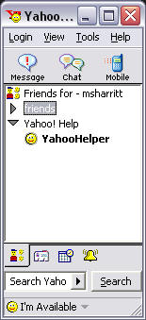  Figure 1, Yahoo! Messenger Friends list | 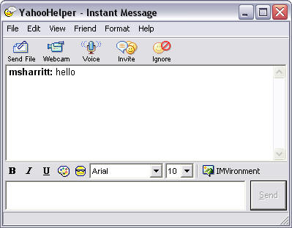  Figure 2, Yahoo! Messenger Chat box
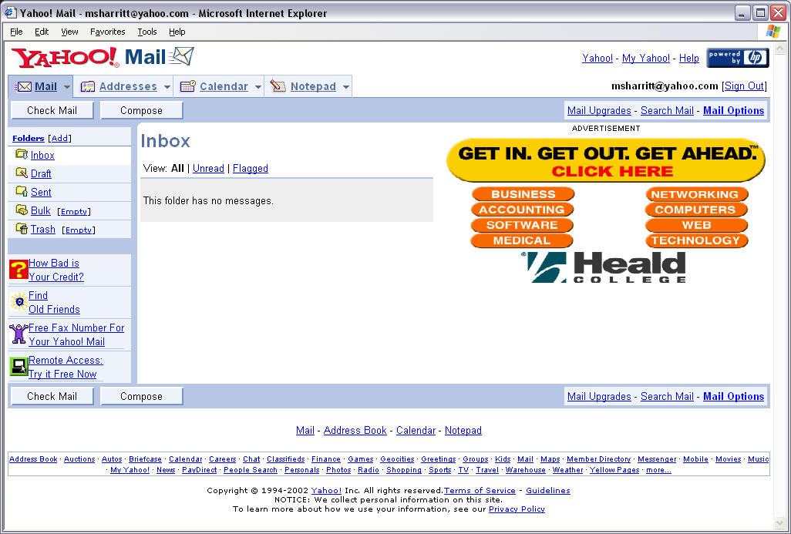  Figure 3, Yahoo! Mail / Calendar / Address Book | 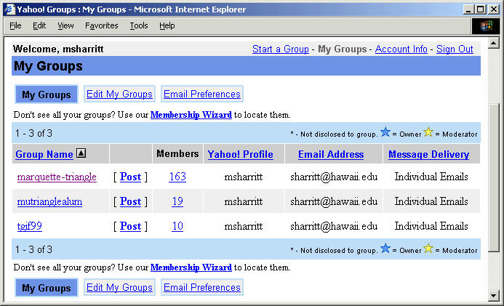  Figure 4, Yahoo! Groups

The Yahoo! Suite of products can be obtained for free and could be useful for telementoring purposes. A downside is that the various products are not truly integrated. Another obvious downside is the software's inclusion of ads in their products, and also the need to download and install some of the products which may for some users require retrieving permission and assistance from a system administrator.

The e-mail program is very good- and has a built in spam filter, so unwanted mail can be filtered out. This could be very useful since some younger students might want to have some sort of filtering installed. The presence of commercial ads may be distracting and unwanted for several reasons.

The Yahoo! Groups page shown above could be used for the purposes of telementoring- basically anyone can start a group in here, and select the members of the group. Once a group is made, any member of the group can send e-mail to the rest of the group address, which then gets distributed to each member of the group. The messages sent to the group is displayed chronologically, but is not threaded. There is no support for search in the neither messages nor the files attached to them. The attached artifacts are only accessible via the message they were originally attached to. There is an area for uploading files, but it is totally disconnected from the group communication.

All in all the products in the Yahoo! suite are not very integrated and should be considered separate software.

The America Online Suite

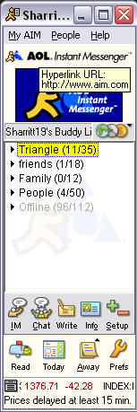  Figure 5, AOL Instant Messenger | 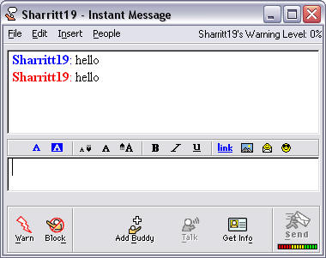  Figure 6, AOL Instant Messenger Chat box

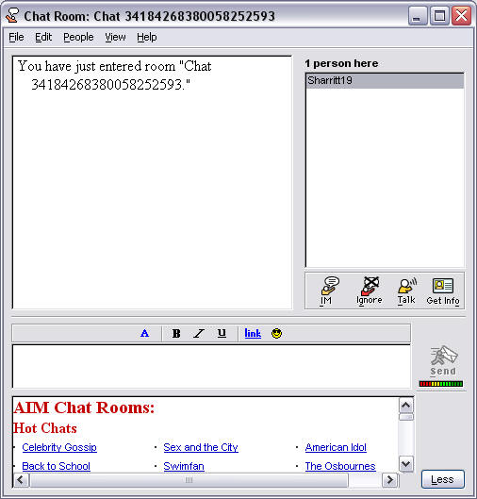  Figure 7, AOL Chat | 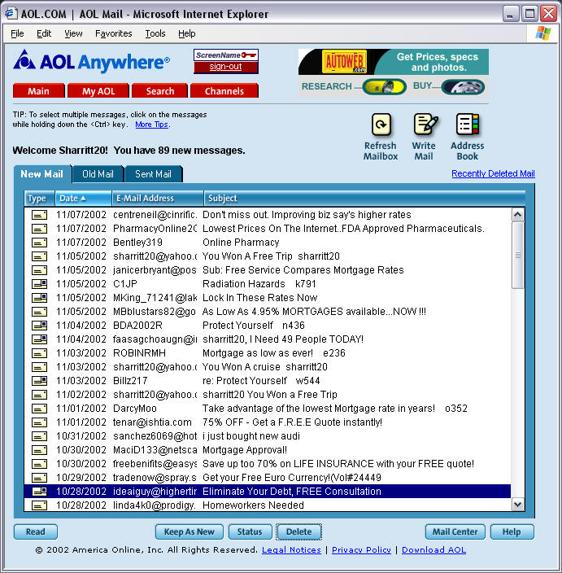  Figure 8, AOL Mail

The America Online suite of products is also useful for the purposes of telementoring. AOL provides (also for free) the ability to sign up for an account on their Instant Messaging program, which automatically gives you an e-mail account. AOL and Netscape have joined, so the Netscape page can be used to get access to AOL Instant Messenger and e-mail. The chat provided is also very good for synchronous communication.

Several of the products in this suit also requires downloading and installation which may for some users require retrieving permission and assistance from a system administrator. The tools in the AOL suit is not integrated, and should rather be considered separate software.

The MSN Suite

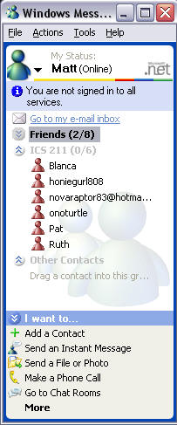  Figure 9, MSN Messenger Friends List | 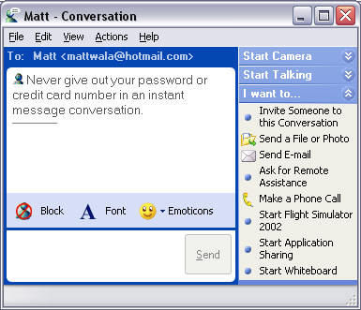  Figure 10, MSN Messenger Chat box
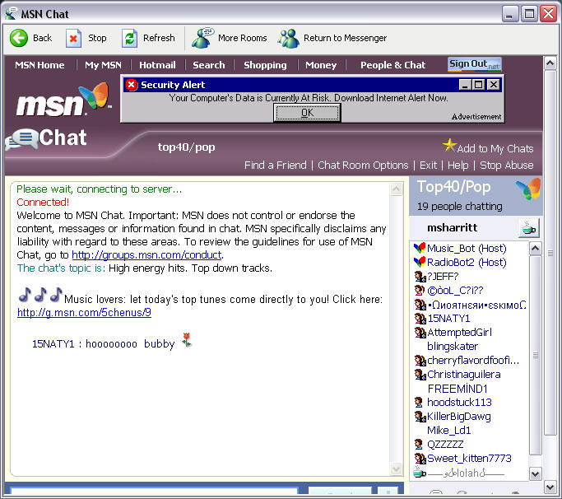  Figure 11, MSN Chat | 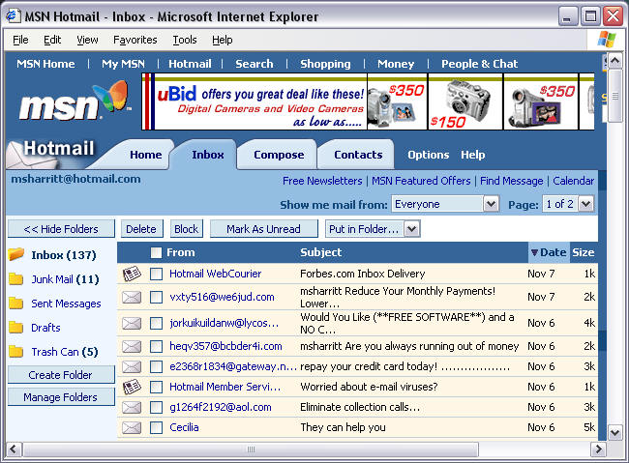  Figure 12, MSN Hotmail (E-mail)

The MSN suite is also available for free, with the obvious downside of having advertising thrown in. However, the tools can be very useful, and the ads don't seem too distracting while you are trying to use the tool. The e-mail, chat and messenger are all very good tools, and each one provides links to the other tools if one chooses to jump from one tool to another. This provides the MNS suite with some product integration and makes it probably the best integration of tools of all the free commercial communication suits we analyzed. But it is by far fully integrated, and leaves much to be wanted on this area.

However, the basic (free) mail program requires you to go through the hassle of selecting interests (so Microsoft can send you spam), and you only get a 2MB e-mail box. For only $19.99 a year you can avoid this, and get a larger e-mail box. The messenger program also have to be downloaded and installed which may for some users require retrieving permission and assistance from a system administrator.

WebCT

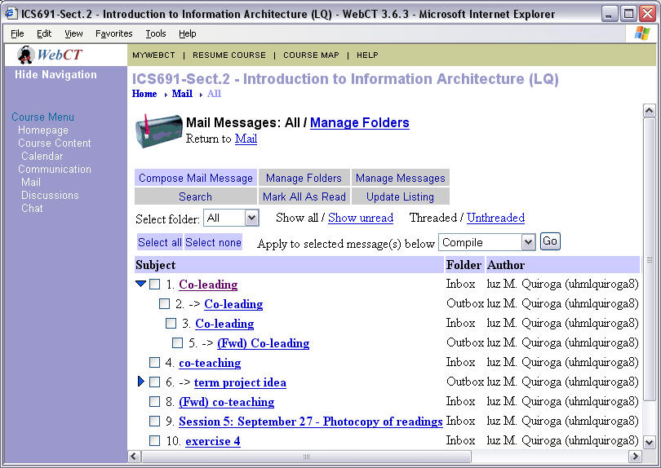  Figure 13, WebCT email | 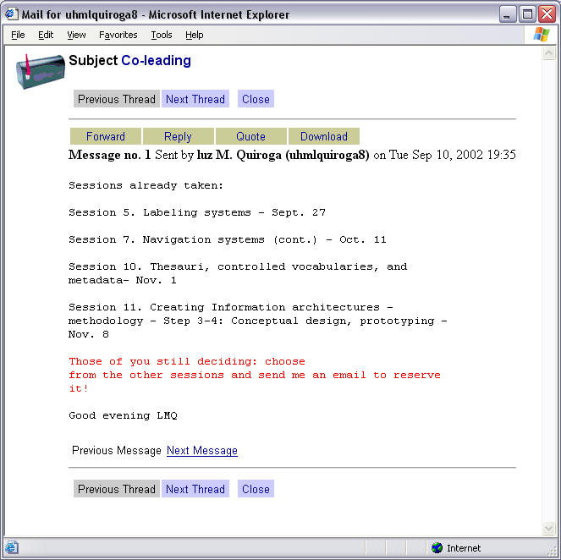  Figure 14, WebCT Individual E-mail
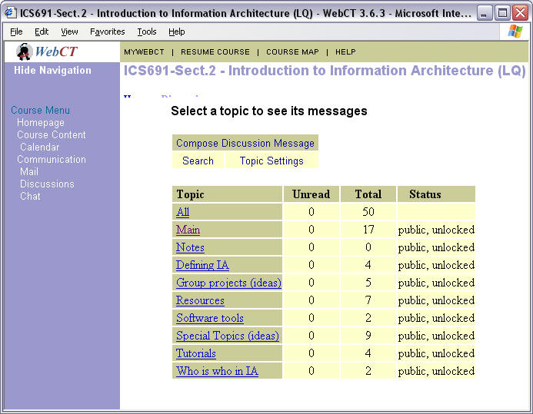  Figure 15, WebCT Discussion | 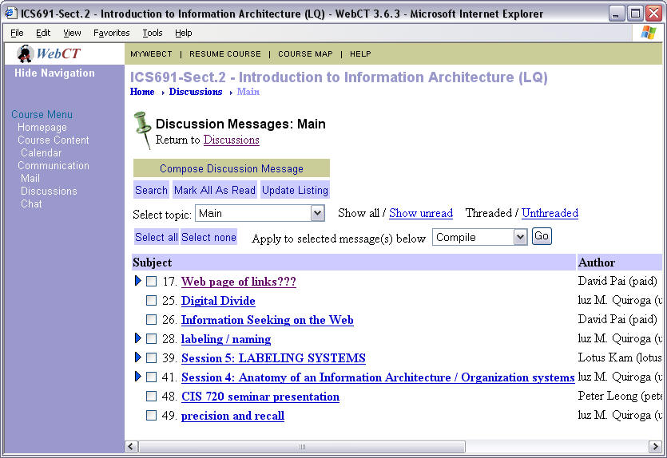  Figure 16, WebCT Discussion Thread

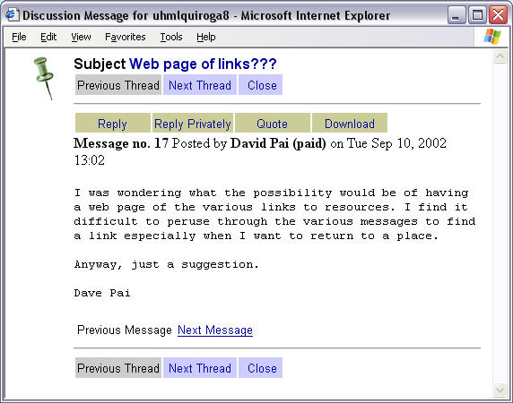  Figure 17, WebCT Discussion Message | 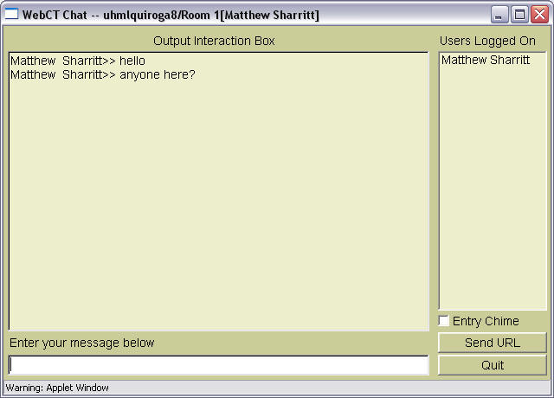  Figure 18, WebCT Chat

The WebCT suite of products provides an integrated set of synchronous and asynchronous tools. All of the above tools are integrated into a web site, and can be tailored to a particular project or class. WebCT doesn't have any distracting ads in their software, and presents an fairly easy interface for anyone to use.

There are still several improvements to be made on the various tools provided by WebCT. E.g. there is no way to search discussion contents and attachments. Neither within a single course nor on the entire system. This system does not support online identity well. There is a "introduction" feature, but this is disconnected from all the other tools.
Since WebCT is designed with online courses in mind it also provides a lot of functionalities not needed for telementoring, like testing and grading, and it is quite expensive.

Conclusion
All of the above tools contain aspects and features useful for mentors, mentees, and supervisors that are looking for ways to communicate with each other. But the various tools are mostly poorly integrated. The free tools has a bonus for those with a low budget, but they all contain components which require downloading and installing software, which requires memory space and may for some users also require retrieving permission and assistance from a system administrator. Any of the three free suites above provide a bit of simplicity in the fact that you only need one login / password to access any of the services. But they all suffer from "sneaking featurism" because of their commercial nature and the expectations of continuously upgrading their products by adding more features. WebCT also has bundled features that are available under the same login and password.

We definitely see the need for a fully integrated system tailored for telementoring, offering artifact sharing and asynchronous and synchronous communication which can be archived in order to preserve useful information for the benefit of others. The system should be accessible to the users via an Internet browser, and not require installing additional software. The system needs to be easy to use and easy to navigate in order to retrieve information, and should be stripped for unnecessary features and functionalities that may confuse and distract the users.

Problem / Activity Scenarios

Scenario 1: Joe, Sue, and Christine study the Northern Light

Background
Joe, Sue, and Christine are students at Greenforest High School in Florida. Mr. Jones is their science teacher. Mr. Jones wants his students to do group projects on natural phenomena, so he asks his students to select project topics they are interested in. He organizes the students in groups of three according to their interests. Joe, Sue, and Christine form the group investigating aurora borealis, northern light. Greenforest High School is participating in a telementoring program called "Science For All"(SFA) where real scientists acts as mentor for high school students involved in project based learning. Through the SFA program Mr. Jones matches all his project groups with scientist specializing on the project topic area. Jane who is a researcher at the International Arctic Research Center in Alaska is matched with the aurora borealis group. Jane has no experience being a telementor, but she have read SFA's brief online telementor guide.

Problem Scenario
The SFA telementoring program uses e-mail for communication between mentors and mentees. Jane starts off the communication by sending an e-mail to the group introducing herself and the Arctic Research Center. Joe, Sue, and Christine compose a reply together presenting themselves and the project they propose to do. After a while Sue starts replying to Jane without consulting the rest of her group. Jane is not aware of Sue acting on her own, and Joe and Christine are not aware of this happening. After a while Jane realizes the situation, but she is insecure about how to handle it as she has no experience with telementoring and this was not covered in SFA's telementor guide. The whole thing makes Jane feel inadequate as a telementor.
When the project group gets project assignments from Mr. Jones they try to make Jane volunteer assignment solutions for them, but Jane politely tells the group that they have to find their own answers, but that she can help them finding relevant information. Joe, Sue, and Christine have got the impression that the other groups get straight answers from their mentors, and starts discussing what a bad mentor Jane is since she won't give them any straight answers.

Activity Scenario
The SFA telementoring program uses the online Telementoring Workspace (TW) provided by Networked Education for Remote Destinations (NERD) Corporation. Joe, Sue, Christine, and Jane get a workspace area in TW dedicated for their telementor-mentee relationship. They start out making their online profiles presenting themselves to their group. Jane tells about her education, her work, and her dog Spot. She also submits a photo of her and Spot. Joe also has a dog, Bingo, so seeing Jane's photo he posts a photo of Bing in his profile. Then they all start discussing the group's project. When Sue starts to reply Jane's postings taking decisions without involving the rest of the group Christine soon discovers this, as all communication in the workspace is visible to everybody. Being new to telementoring Jane is a little surprised by this development, and goes to the telementors' area in TW to discuss this with other telementors. She gets feedback from five other telementors who have experienced something similar and share how they handled the problem.
When the project group gets project assignments from Mr. Jones they try to make Jane volunteer assignment solutions for them, but Jane politely tells the group that they have to find their own answers, but that she can help them finding relevant information. Joe and Sue wonder if it is true that Jane is not supposed to give them direct answers to their questions. They browse through the TW workspace areas of some of the other groups in Mr. Jones science class and look at the communication they have with their telementors. After looking at four other workspace areas they realize that none of the telementors give straight answers to the students' questions. When consulting the telementee's Frequently Asked Questions (FAQs) in TW they learn that the telementors' job is to guide the mentees in finding their own answers rather than giving them the correct answer.

Scenario 2: Elvis studies Peruvian desert mummies

Background
Elvis is an undergraduate student at Knowhow University majoring in archeology. For class about Archeological Discoveries he has to do a large research paper on a topic of his choice. Elvis is fascinated by the desert mummies recently found in Peru, and wants to write a paper on how they were discovered. Dr. Seusse, the instructor of the Archeological Discoveries class, puts Elvis in contact with Dr. Ming who is participating in excavations in the Peruvian deserts.

Problem Scenario
Dr. Seusse suggests that Elvis download an online messaging system and use that to communicate with Dr. Ming. Elvis downloads the messaging system at a computer in the students' computer lab at Knowhow University. When he tries to install it he receives an error message on the computer screen saying only system administrators can install programs on the computer. When Elvis finally locates the system administrator he learns that the software cannot be installed unless Elvis can prove that it is going to be used for research and not leisure. Since Dr. Seusse is away for a conference Elvis have to wait until he gets back in order to get the confirmation the system administrator requested. The day after the software is installed Elvis and Dr. Ming have their first online session. During the chat Dr. Ming sends Elvis some unpublished research papers she has written. They agree to have their next online session late in the evening a week later.
Since Elvis doesn't have access to the university computer lab late in the evening he decides to ask his roommate to install the online messaging system on his computer. An hour before the second online session with Dr. Ming Elvis remembers that he has forgotten to read one of the research papers he received during their last session. But since he was using a computer at the university at that time the document was stored locally at that computer and is not available for Elvis before the online session.
Dr. Seusse is wondering how the telementoring relationship between Dr. Ming and Elvis is developing. He knows that Dr. Ming has very high standards and normally mentors graduate students so he is a little worried that she might demand too much from Elvis. Dr. Seusse feels he can ask neither Dr. Ming nor Elvis about this because it might have a negative effect on the telementoring.

Activity Scenario
Dr. Seusse sets up a workspace area for Elvis and Dr. Ming in the online Telementoring Workspace (TW) provided by Networked Education for Remote Destinations (NERD) Corporation. Dr. Ming has used TW earlier and already has a profile presenting herself, her work, and some of the leisure activities she enjoys, as well as a photo of her and a Peruvian mummy she helped discover. Elvis makes an online profile for himself and start browsing through some of the workspaces from telementor relationships Dr. Ming has previously participated in. He gets really impressed by some of the work presented, and he also get a good impression of how Dr. Ming communicates with her mentees. Elvis starts off the communication by presenting his ideas for a paper about the discovery of the Peruvian Mummies. Dr. Ming responds by suggesting that they meet for a synchronous chat using the chat functionality provided by TW the following Monday.
During their chat session Dr. Ming uploads several research papers in their workspace and gives Elvis a link to a web presentation some of her graduate students have made. All information exchanged between the mentor and mentee is stored in the online workspace so Elvis can access it both from the computers at the university and from his roommate's computer at home.
After a couple of weeks Dr. Seusse visits the workspace area on TW to see how his old friend Dr. Ming and Elvis is getting along. He looks at the discussion postings and the archived chat sessions, and is relieved to see that Dr. Ming seems to be adjusting well to mentoring an undergraduate student for a change.

Scenario 3: Kim is designing a unit plan

Background
Kim got her teaching degree three months ago and is recently hired as the only science teacher at Sonofagun Junior High School. She is planning to have her students do a larger project next semester and is struggling with designing a unit plan that will engage the students, cover teaching standards, and be feasible with the resources she has available. In a teaching magazine she has read about an organization called Knowledge Sharing (KS) that offers telementoring for new teachers, and she contacts them for some help. As a result the KS matches Kim with Linn, a master science teacher at Whatchasay Junior High School with 25 years of teaching experience.

Problem Scenario
The KS teacher telementoring does not have much funding and uses a free commercial online discussion system as the communication medium for telementoring.
Linn creates a username and password and a new discussion in the discussion system. She starts the discussion by posting a message presenting herself and her teaching experience.
The day after Kim creates her username, and logs on the discussion system. She has some problems finding the discussion Linn has created, but then she sees a new discussion called "Linn and Kim's Discussion" when browsing the list of discussions ordered by date of creation. Kim replies to Linn's posting by presenting herself. She also wants to post a new message explaining how far she has gotten planning her project based teaching unit. She has her preliminary plans in a word document, but the discussion forum does not support attachments to the postings, so she tries to copy and paste her document in the message text. It turns out the message text cannot be larger than 1000 characters, so Kim finally writes a short summary of what she has done so far.
When Linn logs on the discussion system two days later she finds Kim's postings as well as a message from someone calling himself "Bob" who appears to be interested in their discussion and suggests that they visit a certain URL address. When Kim reads Bob's message she looks at the Website he mentioned and discovers it is a page promoting racial discrimination. This makes her sad and upset.
Kim wants to have a look at other telementoring discussions in the discussion system to see if they had similar problems, but she had difficulties finding other telementoring discussions. In the discussion system there were hundreds of discussion listed by titles and ordered by date of creation. Kim could not detect any way to search them, neither by topic, keywords, participants, nor contents.

Activity Scenario
Knowledge Sharing uses the online Telementoring Workspace (TW) provided by Networked Education for Remote Destinations (NERD) Corporation to mediate the teacher telementoring. Kim and Linn get a workspace area and Kim starts making her online profile, presenting her educational background, and her professional interests. Linn updates her already existing profile adding that she is the proud grandmother of two months old Tim. Only users validated by KS can participate in any interactive activity supported by TW, but all the information exchanged in the various telementoring relationships is available for the public.
Kim posts a message about her preliminary plans for a project based science unit, and she attaches the text document containing her plans. Linn responds to Kim's plans by asking her what science topic she is considering for her unit. Kim has thought of having "squirrels" as the unit topic as there are several squirrels living in the trees in the Sonofagun schoolyard. She does a search in TW for something concerning "squirrels" and finds two workspaces with "squirrels' as a part of the topic, and four discussions with "squirrels" in the title. In addition to this the search brings back several documents, URLs, and discussion postings related to squirrels. Kim is excited and immediately has a closer look at some of the

Claims Analysis

Claims Analysis for Problem Scenarios

Situation Feature | Pros (+) or Cons (-) of feature
E-mail | + supports asynchronous discussion so the users don't have to be online simultaneously in order to exchange information and opinions  + can attach files  + can be sent to more than one person  - is not accessible for people not taking part in the communication, such as supervisors, parents, and others who may be interested in or benefit from the information exchange  - is not immediate communication  - unless the user is using a receipt feature s/he does not know whether the email has been received or not until the receiver responds to it  - if used to support discussion with multiple participants it can be hard to track the chronology in the discussion  + allows the sender plenty of time to read through and edit their contribution to the discussion
Online Discussions Forums | + supports asynchronous discussion so the users don't have to be online simultaneously in order to exchange information and opinions  - in many discussion forums the users cannot attach artifacts to their postings  - discussion areas rarely supports advanced search functions and it can thus be hard to find all relevant information present  + All communication is archived so that it can be available for other users interested in the discussion topic  - if the access to the discussions is not controlled mischievous persons may post irrelevant and even offending information  + allows the sender plenty of time to read through and edit their contribution to the discussion
Instant Messaging | + immediate, synchronous communication  + supports file transfer  - stores transferred files locally  - requires installing additional software, and not all users have access to do this  - installed software occupies computer memory  - does usually not support message archive in order to save the information contained in the communication  - requires a minimum typing speed in order to not make the other users impatient
Online Chat Forums | + immediate, synchronous communication  - does usually not support file sharing  - requires a minimum typing speed in order to fully participate in a discussion  - does usually not support chat archive in order to save the information contained in the communication

Claims Analysis for Activity Scenarios

Situation Feature | Pros (+) or Cons (-) of feature
Integrated Online Telementoring Workspace | + integrates synchronous and asynchronous communication tools with artifact sharing  + let the users chose which communication tool fits their need  + archives communication and information so it is available later, and other users can benefit from it  + gathers telementoring communication and information related to this in one organized and easily accessible system  + supplies telementors with a private online space to communicate and get support from other telementors
Integrated Online Discussions Forums in Telementoring Workspace | + supports asynchronous discussion so the users don't have to be online simultaneously in order to exchange information and opinions  + supports file sharing  + supports advanced search functions in order to find relevant information  + All communication is archived so that it can be available for other users interested in the discussion topic  + access to the discussions is controlled, while everybody can access discussions only persons with user profiles in TW can post to them  + allows the sender plenty of time to read through and edit their contribution to the discussion
Integrated Online Chat Forums in Telementoring Workspace | + immediate, synchronous communication  + integrated with file sharing feature  - requires a minimum typing speed in order to fully participate in a discussion  + supports chat archive in order to save the information contained in the communication
Integrated Artifact Sharing | + easy to find artifacts related to a certain workspace, discussion, chat session, or topic.  + references to artifacts in discussions and chat sessions helps illustrate the participants' opinions.  + can help keep discussions on topic  - a myriad of different artifacts can be overwhelming
Online profile | + supplies an online identity  + supplies information to other users so they get an impression of who the user is, what background s/he has, etc.  - the user can not control who access this information, but the system can limit access to identified users.

User Role Model

Mentor
Name: | Mentor
Includes roles: | Participant in synchronous / asynchronous communication with mentees, Guiding and supporting mentees in their work, Collaborating with supervisors and other mentors if needed
Specializes roles:
Other related roles:
Background (SBD): | Moderate experience level with computers, browsing the Internet
Expectations (SBD): | Efficient system, easy to use and communicate
Preferences (SBD): | Concerned about reliability- will the tool always be available?
Domain Knowledge: | ___ low ___ medium _X__ high
System Knowledge: | ___ low __X_ medium ___ high
Interaction Profile: | Frequency:___ low _X__ medium ___ high  Intensity:___low __X__ medium ____ high  Volume: ___ low __X__ medium ___ high  ___ predicable _X__ variable ___ unpredictable  ___ concentrated (batched) _X__ distributed  ___ simple __X_ moderate ___ complex  ___ required __X_ discretionary  ___ irregular__X_ regular  ___ continuous _X__ discontinuous  ___ process-driven __X_ user-driven
Information Profile: | Dominant flow: ___ from user ___ to user _X__ balanced  Origin: ___ aural __X_ visual ___ mental process ___ telephone ___ paper ___ other:  Information volume: ___ low _X__medium ___ high  Data complexity: __X_ low ___ medium ___ high
Supporting Capabilities (needed functions, features, facilities): | Functions: Internet connection  Features: Synchronous / Asynchronous communication  Facilities: viewable by Web browser
Usability Objectives (rank or check): | __X_ efficiency __X_ accuracy _X__ reliability _X__ learnability ___ rememberability _X__ clarity _X__ comprehensibilty __X_ attractiveness ___ other:
Other salient role characteristics: | Secure system

Mentee
Name: | Mentee
Includes roles: | Participant in synchronous / asynchronous communication with mentors, Receiving guidance from mentors, Collaborating with other mentees
Specializes roles:
Other related roles:
Background (SBD): | Moderate experience level with computers, browsing the Internet
Expectations (SBD): | Efficient system, easy to use and communicate
Preferences (SBD): | Concerned about reliability- will the tool always be available?
Domain Knowledge: | __X_ low ___ medium ___ high
System Knowledge: | ___ low __X_ medium ___ high
Interaction Profile: | Frequency: _X__ low ___ medium ___ high  Intensity: _X__ low ___ medium ___ high  Volume: _X__ low ___ medium ___ high  ___ predicable _X__ variable ___ unpredictable  ___ concentrated (batched) _X__ distributed  ___ simple __X_ moderate ___ complex  ___ required __X_ discretionary  ___ irregular __X_ regular  ___ continuous _X__ discontinuous  ___ process-driven __X_ user-driven
Information Profile: | Dominant flow: ___ from user ___ to user _X__ balanced  Origin: ___ aural __X_ visual ___ mental process ___ telephone ___ paper ___ other:  Information volume: ___ low _X__medium ___ high  Data complexity: __X_ low ___ medium ___ high
Supporting Capabilities (needed functions, features, facilities): | Functions: Internet connection  Features: Synchronous / Asynchronous communication  Facilities: viewable by Web browser
Usability Objectives (rank or check): | __X_ efficiency __X_ accuracy _X__ reliability _X__ learnability ___ rememberability _X__ clarity _X__ comprehensibilty __X_ attractiveness ___ other:
Other salient role characteristics: | Secure system

Supervisor
Name: | Supervisor
Includes roles: | Supporting and supervising computer mediated communication, Supporting mentees in their work, Collaborating with mentors if needed
Specializes roles:
Other related roles:
Background (SBD): | Moderate experience level with computers, browsing the Internet
Expectations (SBD): | Efficient system, easy to use and communicate
Preferences (SBD): | Concerned about reliability- will the tool always be available?
Domain Knowledge: | ___ low __X_ medium ___ high
System Knowledge: | ___ low __X_ medium ___ high
Interaction Profile: | Frequency:___ low _X__ medium ___ high  Intensity:___low __X__ medium ____ high  Volume: ___ low __X__ medium ___ high  ___ predicable _X__ variable ___ unpredictable  ___ concentrated (batched) _X__ distributed  ___ simple __X_ moderate ___ complex  ___ required __X_ discretionary  ___ irregular__X_ regular  __X_ continuous ___ discontinuous  ___ process-driven __X_ user-driven
Information Profile: | Dominant flow: ___ from user ___ to user _X__ balanced  Origin: ___ aural __X_ visual ___ mental process ___ telephone ___ paper ___ other:  Information volume: ___ low _X__medium ___ high  Data complexity: __X_ low ___ medium ___ high
Supporting Capabilities (needed functions, features, facilities): | Functions: Internet connection  Features: Synchronous / Asynchronous communication  Facilities: viewable by Web browser
Usability Objectives (rank or check): | __X_ efficiency __X_ accuracy _X__ reliability _X__ learnability ___ rememberability _X__ clarity _X__ comprehensibilty __X_ attractiveness ___ other:
Other salient role characteristics: | Secure system

Essential Use Cases

Using the Discussion
User Action | System Response
Pre-condition: none
Selects a message
 | Display the message
Reads the message
Replies to message
 | Accept and display new message
Post-condition: There is a new message added to the discussion

Using Chat
User Action | System Response
Pre-condition: none
Access chat
 | Display chat area
Read chat
Type and send message
 | Display message
Post-condition: There is a new message added to the chat

Searching for Discussions
User Action | System Response
Pre-condition: none
Search discussions
 | Display discussions based on search
Select a discussion
 | Display selected discussion
Select message
 | Display message
Read the message
Post-condition: none

Add a Person as a Friend
User Action | System Response
Pre-condition: none
Search persons
 | Display persons based on search
Select a person
 | Display person's profile
Add person to friend list
 | Confirm person is in friend list
Post-condition: none

Upload File
User Action | System Response
Pre-condition: none
Select file to upload
Submit file
Upload
Confirm
Post-condition: none

Create new workspace
User Action | System Response
Pre-condition: none
Create workspace
Create new workspace
Display customizing form
Customize
Enter workspace specifications
Store
Confirm
Post-condition: none

Look for Recent Activity
User Action | System Response
Pre-condition: none
Scan list of recent activity
Select from list
 | Display recent activity item
Post-condition: none

E-R Model
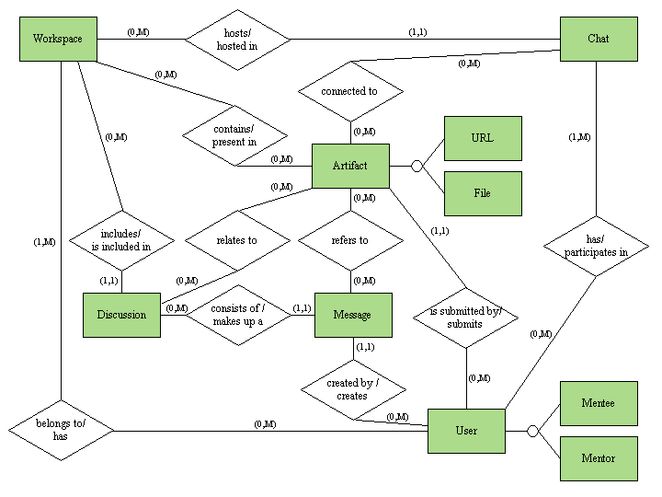

Context Navigation Map
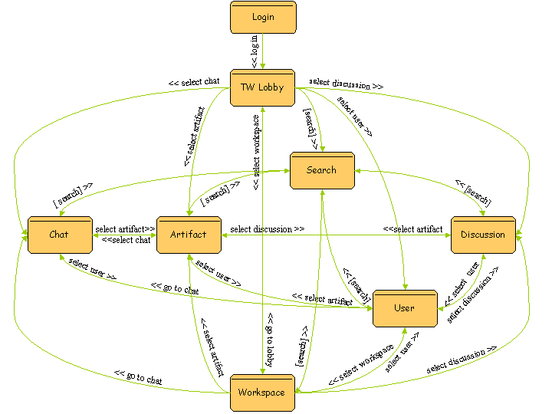

Contexts
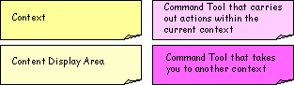

Login View
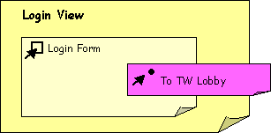

TW Lobby View
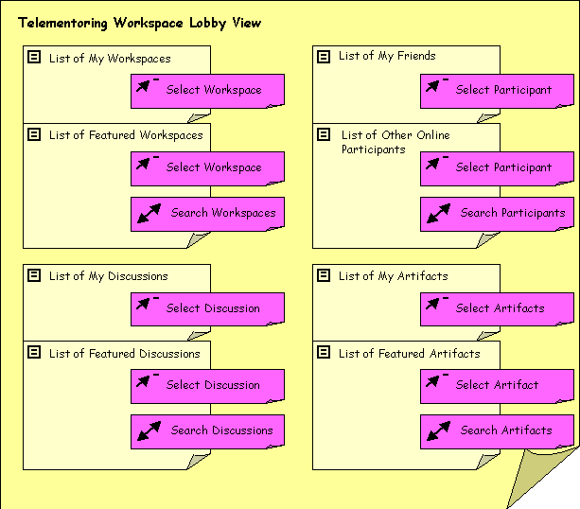

Workspace View
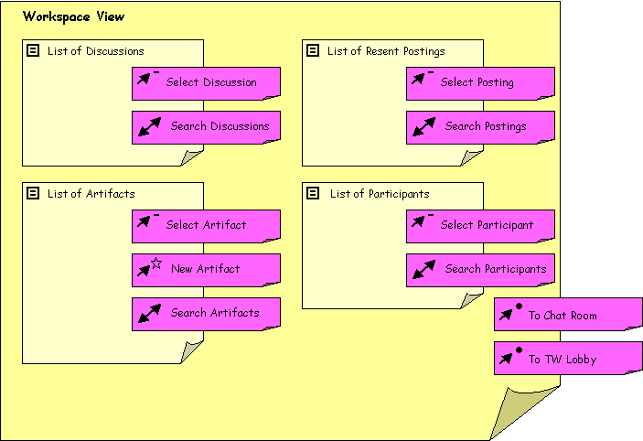

Discussion View
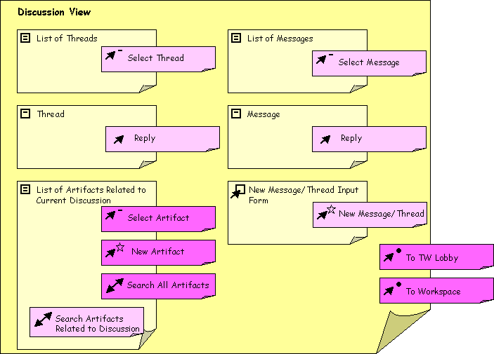

Chat View
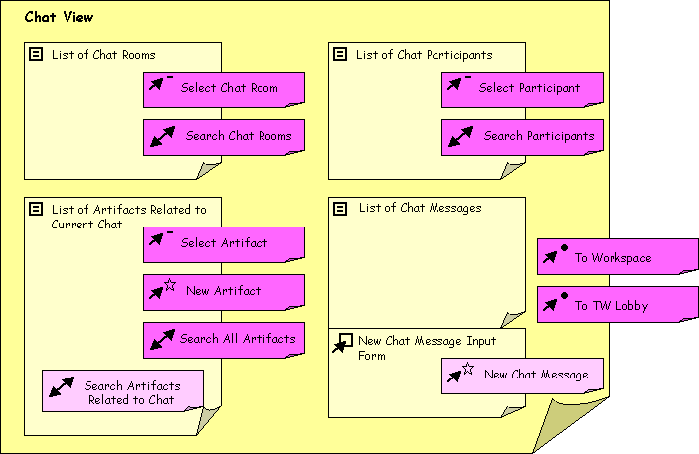

Search View
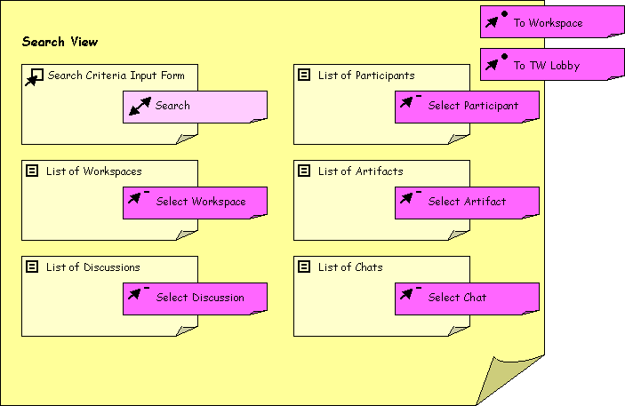

Interaction Scenario

Elvis starts using Telementoring Workspaces
(Based on the problem- and activity scenario Elvis studies Peruvian desert mummies.)

Background
Elvis is an undergraduate student at Knowhow University majoring in archeology. For class about Archeological Discoveries he has to do a large research paper on a topic of his choice. Elvis is fascinated by the desert mummies recently found in Peru, and wants to write a paper on how they were discovered. Dr. Seusse, the instructor of the Archeological Discoveries class, puts Elvis in contact with Dr. Ming who is participating in excavations in the Peruvian deserts.

Interaction Scenario
Dr. Seusse suggests that Elvis register on Telementoring Workspace (TW), and set up a workspace so that he, Dr. Ming and Dr. Seusse can communicate and work with each other.
Elvis then goes to Knowhow University's TW web site, and registers as a student in the TW system. By registering Elvis has created a personal profile in TW identified by a user name and password, which he uses to log in to the system. He is then taken to the TW lobby where he finds his profile and adds some information about himself, so that Dr. Ming and Dr. Seusse can find out more about him if they wish.
Elvis returns to the TW lobby, and decides that he will set up a new workspace for himself, Dr. Seusse and Dr. Ming to work together. Elvis selects the create option under workspaces and then fills out the workspace customization form that sets the properties of the "Peruvian Desert Mummies" workspace. Having created a new workspace Elvis selects the create option under discussions and completes the create new discussion form creating a new workspace discussion called "project proposal" that refers to his project.doc file, which he submits as a discussion artifact. This discussion is where he hopes that he and Dr. Ming can meet and discuss his project proposal by asynchronous communication. Elvis starts off the discussion by creating a new thread. When he gets back to the workspace overview he can see his latest actions summarized as "Recent Activities in this Workspace". When Elvis goes to the TW lobby he notices that his latest actions also are summarized there.
Elvis notices his friends list, which he will use to see if any of his friends are logged on to the TW system while he is. Since he just registered at TW his friends list is empty, and he sets out to search for Dr. Ming so he can add him. When Elvis again returns to the TW lobby he sees that Dr. Ming is online.

Prototype
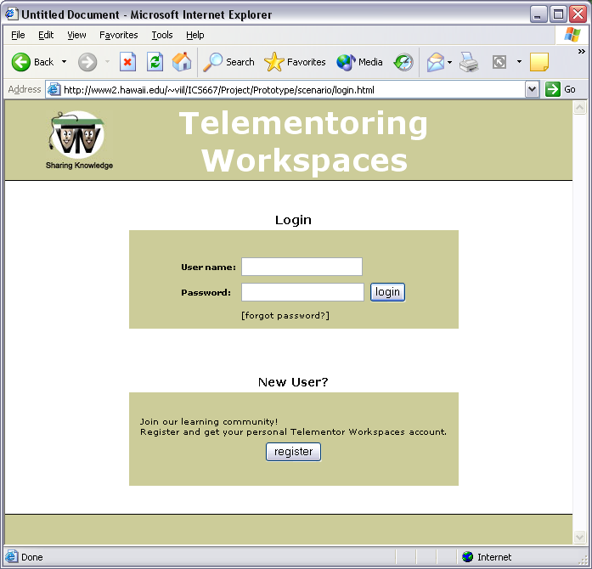 | 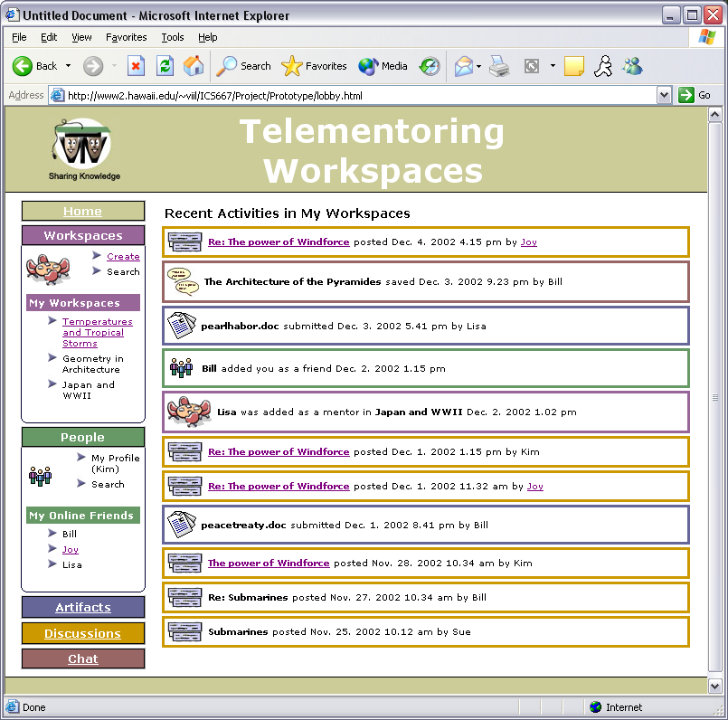
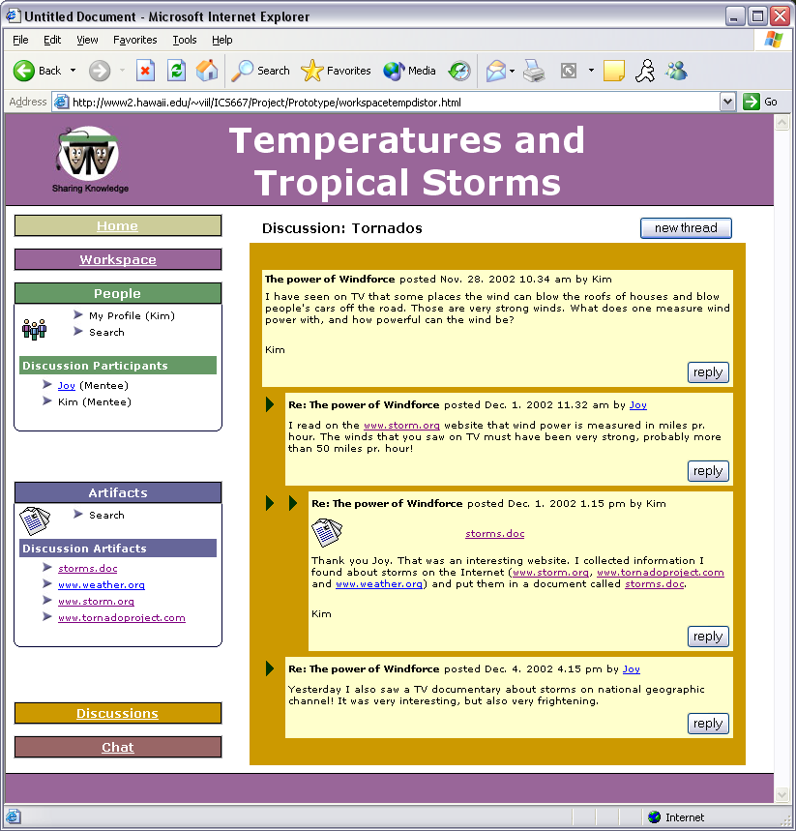 | 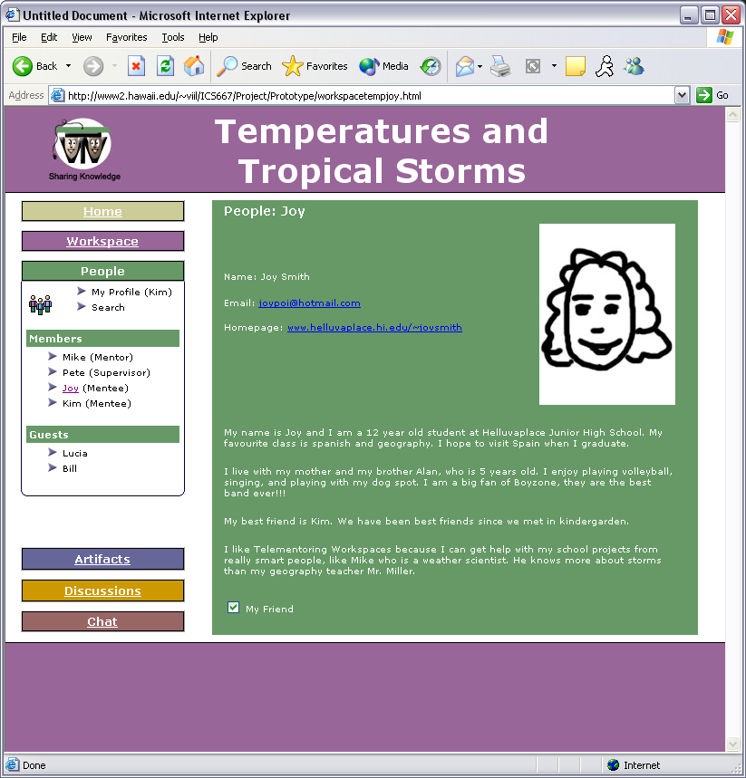
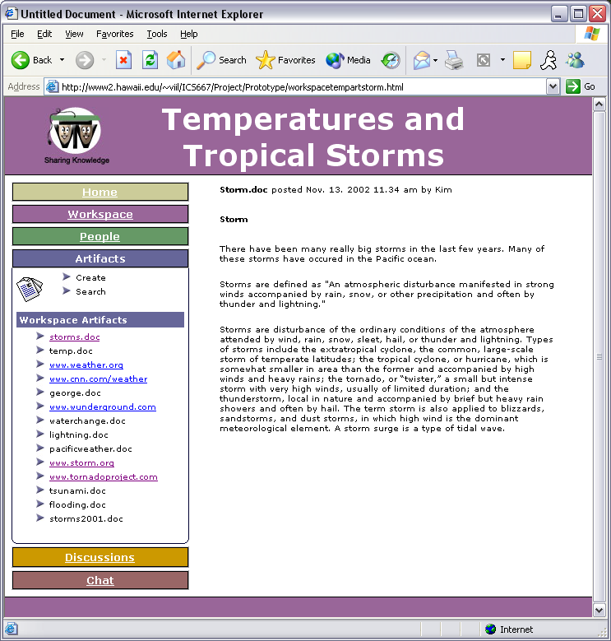 | 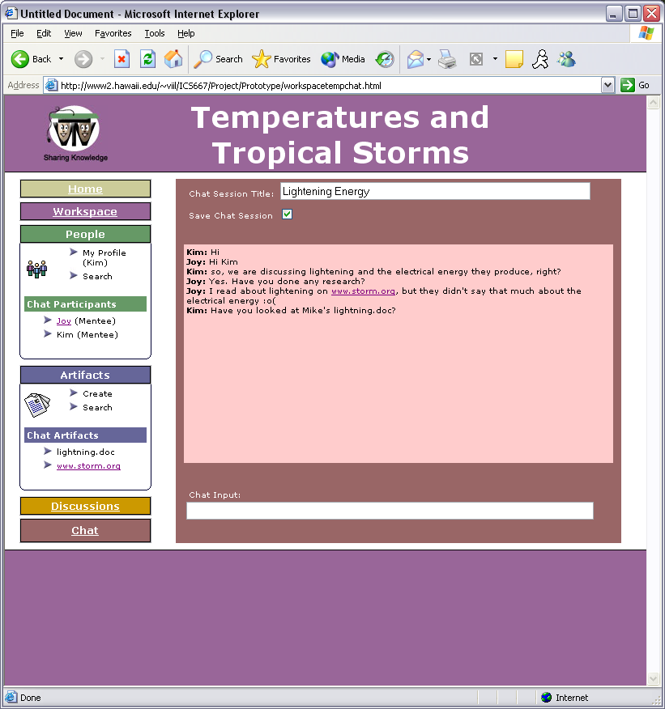

Icon Testing
Users' Interpretation of the Icons

Method
In our prototype of Telementoring Workspaces the icons are accompanied by headers and/or text implying their meaning, but we wanted to know how well the icons represented what we intended them to symbolize.
Before introducing the prototype we asked the users to have a look at the icons separately and give their interpretation of what they may symbolize.

Result
Icon | Our Intention | User 2 | User 2 | User 3 | User 4 | Summary
 | Telementoring Workspaces Logo. | This looks like two CPU connected to one another. Networking between two users. | A collaborative space for people to share ideas. | Sharing with another person in the class. | Send files, email, share other's files. | The users seem to get the general idea of collaboration and sharing.
 | Discussion. | This looks like two keyboards connected to one another. Maybe this could be for some sort of networking. | No clue, maybe dialogue boxes implying some form of message postings (bulletin board). | Bricks? Hard drive? | Chart, graph, some sort of hierarchy. | This icon needs to be replaced; none of the users interpreted it correct.
 | Workspace. | This is a conference icon. | An online conference room or meeting area. | Group meeting, discussion. | Workgroup. | The users seem to get the general idea of a place for collaboration.
 | Chat. | This may represent dialog among two people. So maybe some sort of instant messaging. | A chat area or maybe a discussion area | Dialogue, questions. | Chat, talk with other people online. | The users seem to get the general idea of dialogue, and chat.
 | People. | This could be a chat room or a conference room. | Hmmm… obviously people, but not sure what they would signify | Group. | Workgroup, people in your workgroup. | The users seem to get the general idea of people, and people collaborating.
 | Artifacts. | This is an icon for writing a paper or major project. Maybe this is an icon for a document. | A place where papers or references are available… maybe resources. | Test. | Post projects, documents. | It was fairly easy to recognize the document. How to visually represent "artifact"?

Prototype Testing

Method
We asked each of our test users to try the prototype. They were informed about the general purpose of the system, and that they would be logged on as "Kim", who had been using the system for some time.
We then gave the users a list of tasks to complete in the system.

Tasks
- Find out which workspaces you are a member of.
- Find your friend Joy's email address.
- Find out the name of your mentor in the workspace "Temperatures and Tropical Storms".
- Find out what has happened in the "Temperatures and Tropical Storms" workspace since Dec. 4th.
- Find out how many artifacts have the word "storm" in their title in the "Temperatures and Tropical Storms" workspace.

Since any interaction like "search", "discussions", "chat" would involve a non existing back end to the system we had to concentrate our tasks about finding what was already easily available in our prototype.
Since all the users were new to the system we did not find it purposeful to time any of the tasks. We concentrated on gathering data about the users' impression and interpretation of the system by asking them to think out loud as they were trying to complete their tasks.

Prompts when the user forgets to think out loud
- What are you looking for?
- Why are you looking for that?
- What are you expecting it to do?
- What are you trying to do?
- Did you expect what just happened?

After the tasks were completed we asked the users some additional questions while they were encouraged to play around with the system.

Additional questions
- What aspects of the system did you like/dislike, and why?
- What was your overall impression of the system?
- Do you have any suggestions for improvements?

Results

Feature | User 1 | User 2 | User 3 | User 4 | Summary
Front page | Also I would not have my recent activities displayed on the front page. It takes up most of the space. I would have a link that says recent activities and then if you choose to see them then go for it.  I don't understand why the Workspaces and Artifacts icons are always open on the front page. | The recent activity portion is nice. | Maybe replace the icons for recent activities with color-coding?  The front page is too beige. | I like the icons for the various recent activities. Icons are easy to relate to for web literates. | Disagreement whether recent activities on the front page are a waste of space.  Disagreement whether the Icons labeling the recent activities should be there or not.  Workspace and Artifact lists should be collapsible in the final system.  Dislike of the main color of the front page (beige). may be due to white text which makes it pretty pale.
Workspaces |  |  |  | I expected the workspace to be a conference room. I was not prepared for the different topics. | Labeling of the workspaces in addition to topic title.
Links | I found the links to be labeled correctly. When I clicked on a link I was told what to do next and that was very helpful. | External links leaving the site open in the same window- typically they should open a new window so you don't actually leave the web site. |  | I like the fact that the links follow the standard: blue underlined text. | Links are OK.  External links should open a new window.
Discussions | I feel that the discussion section would be very easy to use. |  |  | I found it confusing that the discussion topics vary from where you are in the system. | Confusing that the discussion topics are displayed in relation to what workspace one is in.  Discussion tool itself would be easy to use.
Chat | I would have the saved chats be dated so that the user does not get confused. |  | I have never been to a chat room, so I hesitate to go there.  (Observation: once in the chat the user soon tried to participate) | I like the fact that one has the option of saving a chat session or not.  (Observation: user immediately tried to post in the chat) | Positive that one can save chat sessions.  Saved chat sessions should be dated.  Observation: users intuitively understood how to use the chat tool.
Artifacts |  | I'm not really clear what an artifact is. Is it a document? |  | I didn't know what an artifact was, but I learned it from the interface.  Good that one can share artifacts. | The label "Artifact" should be replaced.  Positive to sharing artifacts.
People |  | I'm not really sure what the 'Guests' under 'People' is used for, or why it's there. Under 'friends', clicking the friend opens their profile. If they are already your friend, you probably know what their profile is, so it seems unnecessary. |  | I like the personal profiles, so you can "get to know" your group members. | The function of the workspace "guests" was not illustrated in the prototype.  Personal profiles are good.  Linked friend was expected to be a instant messaging system.
Navigation |  | The site could use more trails to show where you are. If you get deep into something, it would be easier to step out if there were breadcrumbs. In the discussion, if you click on a topic, then on a document, there is no way to get back where you were, with the exception of the back button. You're basically lost. |  |  | Breadcrumbs would make it easier for the user to get oriented in the system, and navigate.
Layout | I like the way that the interface is laid out. I feel that it is very user friendly. | Sensible layouts / options | All the links are on the left side and this makes it easy to see what is available. | I like the left hand menu. | Layout is OK.
Icons |  | Good icons | What about using some Hawaiian icons? | I like the icons for the various recent activities. Icons are easy to relate to for web literates. | They liked the use of icons.  Hawaiian icons? (System is not intended to be limited to a Hawaiian market).
Font |  |  | The font is too small. The menu and the headers are OK size. | Maybe increase the font size in the mid section, but at the same time will larger fonts look more unprofessional.  The size of the headings is good. | Increase font on the main text.  Headings are OK.
Colors |  |  | The front page is too beige. | I like the color-coding, but I prefer other colors (not the brown). I would like more matching colors. | Color-coding is helpful.  Need a more pleasant color scheme.
Missing features |  | Breadcrumbs would be very useful.  When clicking on a friend I'd expect to send them an instant message. |  |  | Breadcrumbs.  Instant messaging.
Overall impression | While looking through the website I concluded that it was very user friendly. | I think the web site is very straightforward and makes sense.  Otherwise the site is great, and does what I would expect it to do.  Overall it was very user friendly with good icons and sensible layouts / options.  Overall impression was that the site looked very good, was user friendly, and easy to understand. | I liked the system, and I find it useful for students and mentors. | My overall impression of the system is that the layout was good, but I did not like the colors.  On a scale from 1 to 5 I would definitely give it at least a 4. | User friendly.  Makes sense.  Does what is expected.  Easy to understand.  Looked good.  Disliked colors.  Good layout.

